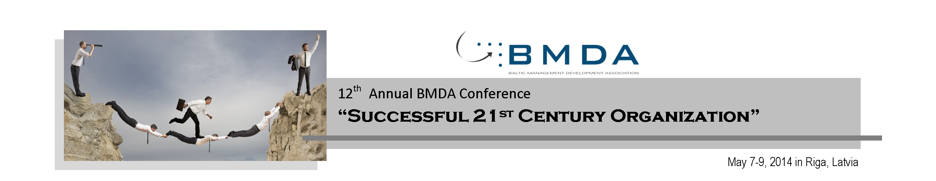

ABSTRACT FORM
The Researchers wanting submit the abstracts for the Research part (May 7, 2014) of the 12th Annual BMDA Conference have to fill in the conference ABSTRACT FORM bellow:
Author(s) name(s) and surname(s):
Academic degree:
Institution:
Position:
Country:
Email:
Telephone:

Paper title:
Indicate the track chosen: | 1. The Role of Leader Empowering Success of the Organization  2. Innovation and Technology Transfer for Bridging Academia and Business  3. Sustainability and Social Responsibility Practices Leading to Success of an Organization  4. The Role and Impact of Higher Educational Institutions on Success of the Company

Purpose:
Please fill in the grey gap bellow describing the reason(s) for writing the paper or the aims of the research.
(up to 600 characters with spaces, ~100 words)
Design/ Methodology/Approach:
Please fill in the grey gap bellow describing how are the objectives achieved. Include the main method(s) used for the research. What is the approach to the topic and what is the theoretical or subject scope of the paper?
(up to 300 character with spaces, ~50 words)
Findings:
Please fill in the grey gap bellow describing what was found in the course of the work.
(up to 600 characters with spaces, ~100 words)
Research limitations/implications:
Please fill in the grey gap bellow describing suggestions for future research and any identified limitations in the research process. (up to 600 characters with spaces, ~100 words)
Practical implications:
Please fill in the grey gap bellow describing identified outcomes and implications for practice, applications, and consequences. How will the research impact upon the business or enterprise? What changes to practice should be made as a result of this research? What is the commercial or economic impact? (up to 600 characters with spaces, ~100 words)
Social implications:
Please fill in the grey gap bellow describing the social implications. What will be the impact on society of this research? How will it influence public attitudes? How will it influence corporate/ social responsibility or environmental issues? How could it inform public or industry policy? How might it affect the quality of life? (up to 600 characters with spaces, ~100 words)
Originality/value:
Please fill in the grey gap bellow describing what new was discovered in the paper. (up to 300 character with spaces, ~50 words)
Keywords:
Use the keywords that are specific and reflect what is essential about the paper. Each keyword should start from a capital letter and should be separated by comma.

The abstract forms should be submitted by e-mail to projects@bmda.net until 9th April, 2014

